Project
  - Deadline: Monday, 4/5/2026 @ 23:59
[Total Mark for this Assignment is 14]

Web Programming
DS362
Students Details: CRN: ###
Name: Farah Alhelal |  | ID: S230032898
z
Instructions:
- You must submit two separate copies (one Word file and one PDF file) using the Assignment Template on Blackboard via the allocated folder. These files must not be in compressed format.
- It is your responsibility to check and make sure that you have uploaded both the correct files.
- Zero mark will be given if you try to bypass the SafeAssign (e.g. misspell words, remove spaces between words, hide characters, use different character sets or languages other than English or any kind of manipulation).
- Email submission will not be accepted.
- You are advised to make your work clear and well-presented. This includes filling your information on the cover page.
- You must use this template, failing which will result in zero mark.
- You MUST show all your work, and text must not be converted into an image, unless specified otherwise by the question.
- Late submission will result in ZERO mark.
- The work should be your own, copying from students or other resources will result in ZERO mark.
- Use Times New Roman font for all your answers.

Project
14 Marks
Learning Outcome(s):
2. Create web pages using HTML5 and CSS3.
3. Develop dynamic web pages using JavaScript.
6. Build web applications using PHP and MySQL.
In this project, you need to build a website based on one of the suggested project ideas below. Your project should be from one of the below ideas. You can work on it individually or as a group of a maximum of 3 members.

Suggested Project ideas
- Online Course Registration System: Home page, Users register/login page, course listing page, course enrollment page, and enrollment history page.
- Hotel Booking Website: Home page, Users register/login page, room search page, room details page, and booking history page.
- Online Shopping Website: Home page, Users register/login page, product categories page, shopping cart page, and order history page.
- Clinic Appointment System: Home page, Users register/login page, doctors listing page, appointment booking page, and appointment history page.
The website must cover all the following aspects of the course (HTML, CSS, JavaScript, PHP, MySQL).
Technology | Description | Mark
HTML | HTML Web elements (header, footer, list, table, form …) | 4
 | Navigation (Links are clear and located in the same area on each page. All links are functional)
CSS | Design (using CSS) Website demonstrates design principles: with consistent alignment, proximity, repetition, and contrast… | 3
JavaScript | Form validation, input/output | 2
PHP and MySQL | Create and populate a database in MySQL (1-2 tables). | 5
 | Select records from MySQL database using PHP
 | Insert records into MySQL database using PHP
 | Update records into MySQL database using PHP
 | Delete records from MySQL database using PHP
Total |  | 14

Important notes:
- The number of Web pages within the website must be at least 3 pages.
- The number of dynamic Web pages (using JavaScript) must be at least 2 pages.
- The Website must connect to a database (1 Select + 1 Insert + 1 Update and 1 Delete queries) and take a screenshot for each one.
- For form validation, at least one popup message must appear after the submit button has been clicked. The message must contain a list of all validation errors on the Web page.
- The project needs to be submitted in BB (as an assignment) by ONE of the group members. Your instructor will create the submission link.
- Your HTML, CSS, JavaScript, PHP and MySQL codes/scripts that you paste into your answer part of this file must be editable, not screenshots.
- You need to take screenshots from each output pages and paste them into your answer in this file.
- Your project must be original work. The project will be checked using a plagiarism tool. Any matching with an online project, AI work or another/previous student project will be given ZERO.
- The maximum number of students in the group is 3. Only the group leader will upload the final report on the blackboard.

Presentation:
- Each group needs to make a presentation OR a video recording (based on your instructor) of their project. The presentation date will be announced later by your instructor.
- The maximum time for a presentation is 5 mins.
- In a presentation case, All the group members need to present.
- In both presentation and video recording cases, no need to make PowerPoint slides. You need to run/demonstrate your project pages and present their functionality and interfaces/pages.
Files to submit/upload:
- IT361_Project.docx:
A word file of the project that contains your answer.
- IT361_Project.pdf
A PDF file of the project that contains your answer.
- IT361_Project.zip:
Contains all the coding files of the project (HTML, CSS, images JavaScript, PHP and MySQL).

HTML
4 Marks
Learning Outcome(s):
2. Create web pages using HTML5 and CSS3.

Index.html
<?php session_start(); include("includes/setup.php"); ?>
<!DOCTYPE html>
<html><head><title>StayEasy</title><link rel="stylesheet" href="css/style.css"></head>
<body>

<?php session_start(); ?>

<header class="main-header">
<div class="logo">StayEasy <span>Hotel</span></div>

<nav>
<a href="index.php">Home</a>
<a href="search_rooms.php">Find Rooms</a>

<?php if(isset($_SESSION['user'])){ ?>
<a href="my_bookings.php">My Bookings</a>
<a href="logout.php">Logout</a>
<?php } else { ?>
<a href="login.php">Login</a>
<?php } ?>
</nav>
</header>

<section class="hero"><img src="images/banner.jpg"></section>
<footer><p>Student Project IT361</p></footer>
</body></html>

Login.html
<?php
session_start();
include("includes/setup.php");

if(isset($_POST['login'])){
$u = trim($_POST['username']);
$p = md5(trim($_POST['password']));

$res = mysqli_query($conn,"SELECT * FROM users_simple WHERE username='$u'");

if(mysqli_num_rows($res)>0){
$row = mysqli_fetch_assoc($res);

if($row['password'] == $p){
$_SESSION['user']=$u;
header("Location: index.php");
} else {
echo "<script>alert('Wrong password');</script>";
}
} else {
echo "<script>alert('User not found');</script>";
}
}
?>

<html>
<head>
<link rel="stylesheet" href="css/style.css">
<link href="https://fonts.googleapis.com/css2?family=Poppins:wght@300;400;600&display=swap" rel="stylesheet">
</head>
<body>

<div class="form-box">
<h2 style="text-align:center;">Login</h2>

<form method="POST">
<input type="text" name="username" placeholder="Username">
<input type="password" name="password" placeholder="Password">
<button class="btn" name="login">Login</button>
</form>

<p style="text-align:center;">
<a href="register.php">Create account</a>
</p>
</div>

</body>
</html>

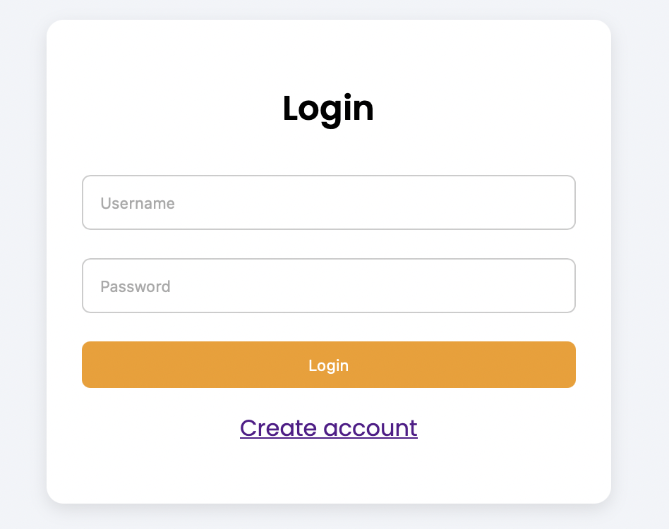

This page allows users to log in using their username and password. It checks the entered data with the database using PHP and displays error messages if the login fails.

Register.html
<?php
include("includes/setup.php");

if(isset($_POST['register'])){
$u = trim($_POST['username']);
$p = md5(trim($_POST['password']));

mysqli_query($conn,"INSERT INTO users_simple(username,password) VALUES('$u','$p')");
header("Location: login.php");
}
?>

<html>
<head>
<link rel="stylesheet" href="css/style.css">

<link href="https://fonts.googleapis.com/css2?family=Poppins:wght@300;400;600&display=swap" rel="stylesheet">

<script>
function validateForm(){
let u = document.getElementById("user").value;
let p = document.getElementById("pass").value;

if(u=="" || p==""){
alert("Please fill all fields");
return false;
}

if(p.length < 4){
alert("Password must be at least 4 characters");
return false;
}

return true;
}
</script>

</head>

<body>

<div class="form-box">

<h2 style="text-align:center;">Create Account</h2>

<form method="POST" onsubmit="return validateForm()">

<input type="text" name="username" id="user" placeholder="Username">

<input type="password" name="password" id="pass" placeholder="Password">

<button class="btn" name="register">Register</button>

</form>

<p style="text-align:center;">
Already have an account? <a href="login.php">Login</a>
</p>

</div>

</body>
</html>

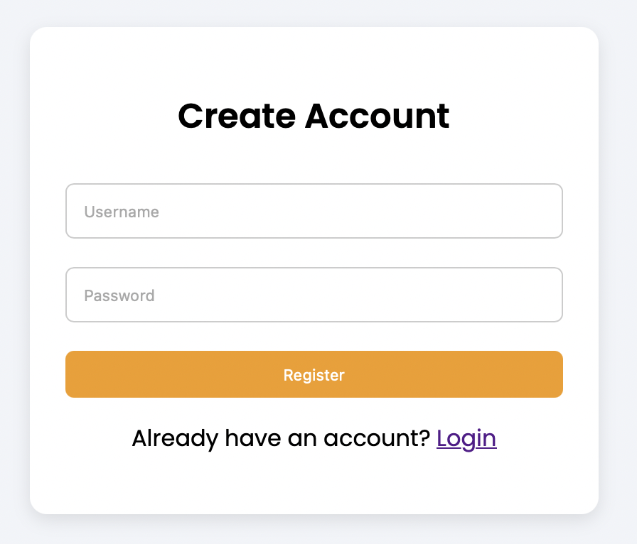

This page allows new users to create an account. It uses JavaScript validation to check inputs before sending data to the database.

Seach room page :
<?php
include("includes/setup.php");
$res = mysqli_query($conn,"SELECT * FROM hotel_rooms");
?>

<html>
<head>
<link rel="stylesheet" href="css/style.css">
<link href="https://fonts.googleapis.com/css2?family=Poppins:wght@300;400;600&display=swap" rel="stylesheet">

<script>
function filterRooms(){
let input = document.getElementById("searchBox").value.toLowerCase();
let minPrice = document.getElementById("minPrice").value;
let cards = document.getElementsByClassName("room-card");

for(let i=0;i<cards.length;i++){
let text = cards[i].innerText.toLowerCase();
let price = cards[i].getAttribute("data-price");

if(text.includes(input) && (minPrice=="" || price >= minPrice)){
cards[i].style.display = "block";
} else {
cards[i].style.display = "none";
}
}
}
</script>

</head>

<body>

<?php session_start(); ?>

<header class="main-header">
<div class="logo">StayEasy <span>Hotel</span></div>

<nav>
<a href="index.php">Home</a>
<a href="search_rooms.php">Find Rooms</a>

<?php if(isset($_SESSION['user'])){ ?>
<a href="my_bookings.php">My Bookings</a>
<a href="logout.php">Logout</a>
<?php } else { ?>
<a href="login.php">Login</a>
<?php } ?>
</nav>
</header>

<div class="page-container">

<h2 class="page-title">Find Your Room</h2>

<div class="filter-box">
<input type="text" id="searchBox" onkeyup="filterRooms()" placeholder="Search room">
<input type="number" id="minPrice" onkeyup="filterRooms()" placeholder="Min price">
</div>

<div class="room-grid">

<?php while($row=mysqli_fetch_assoc($res)){ ?>
<div class="room-card" data-price="<?php echo $row['price']; ?>">

<img src="<?php echo $row['img']; ?>">

<div class="room-content">
<h3><?php echo $row['room_name']; ?></h3>
<p class="price">$<?php echo $row['price']; ?> / night</p>

<a class="btn" href="room_view.php?id=<?php echo $row['id']; ?>">
View Details
</a>
</div>

</div>
<?php } ?>

</div>

</div>

</body>
</html>
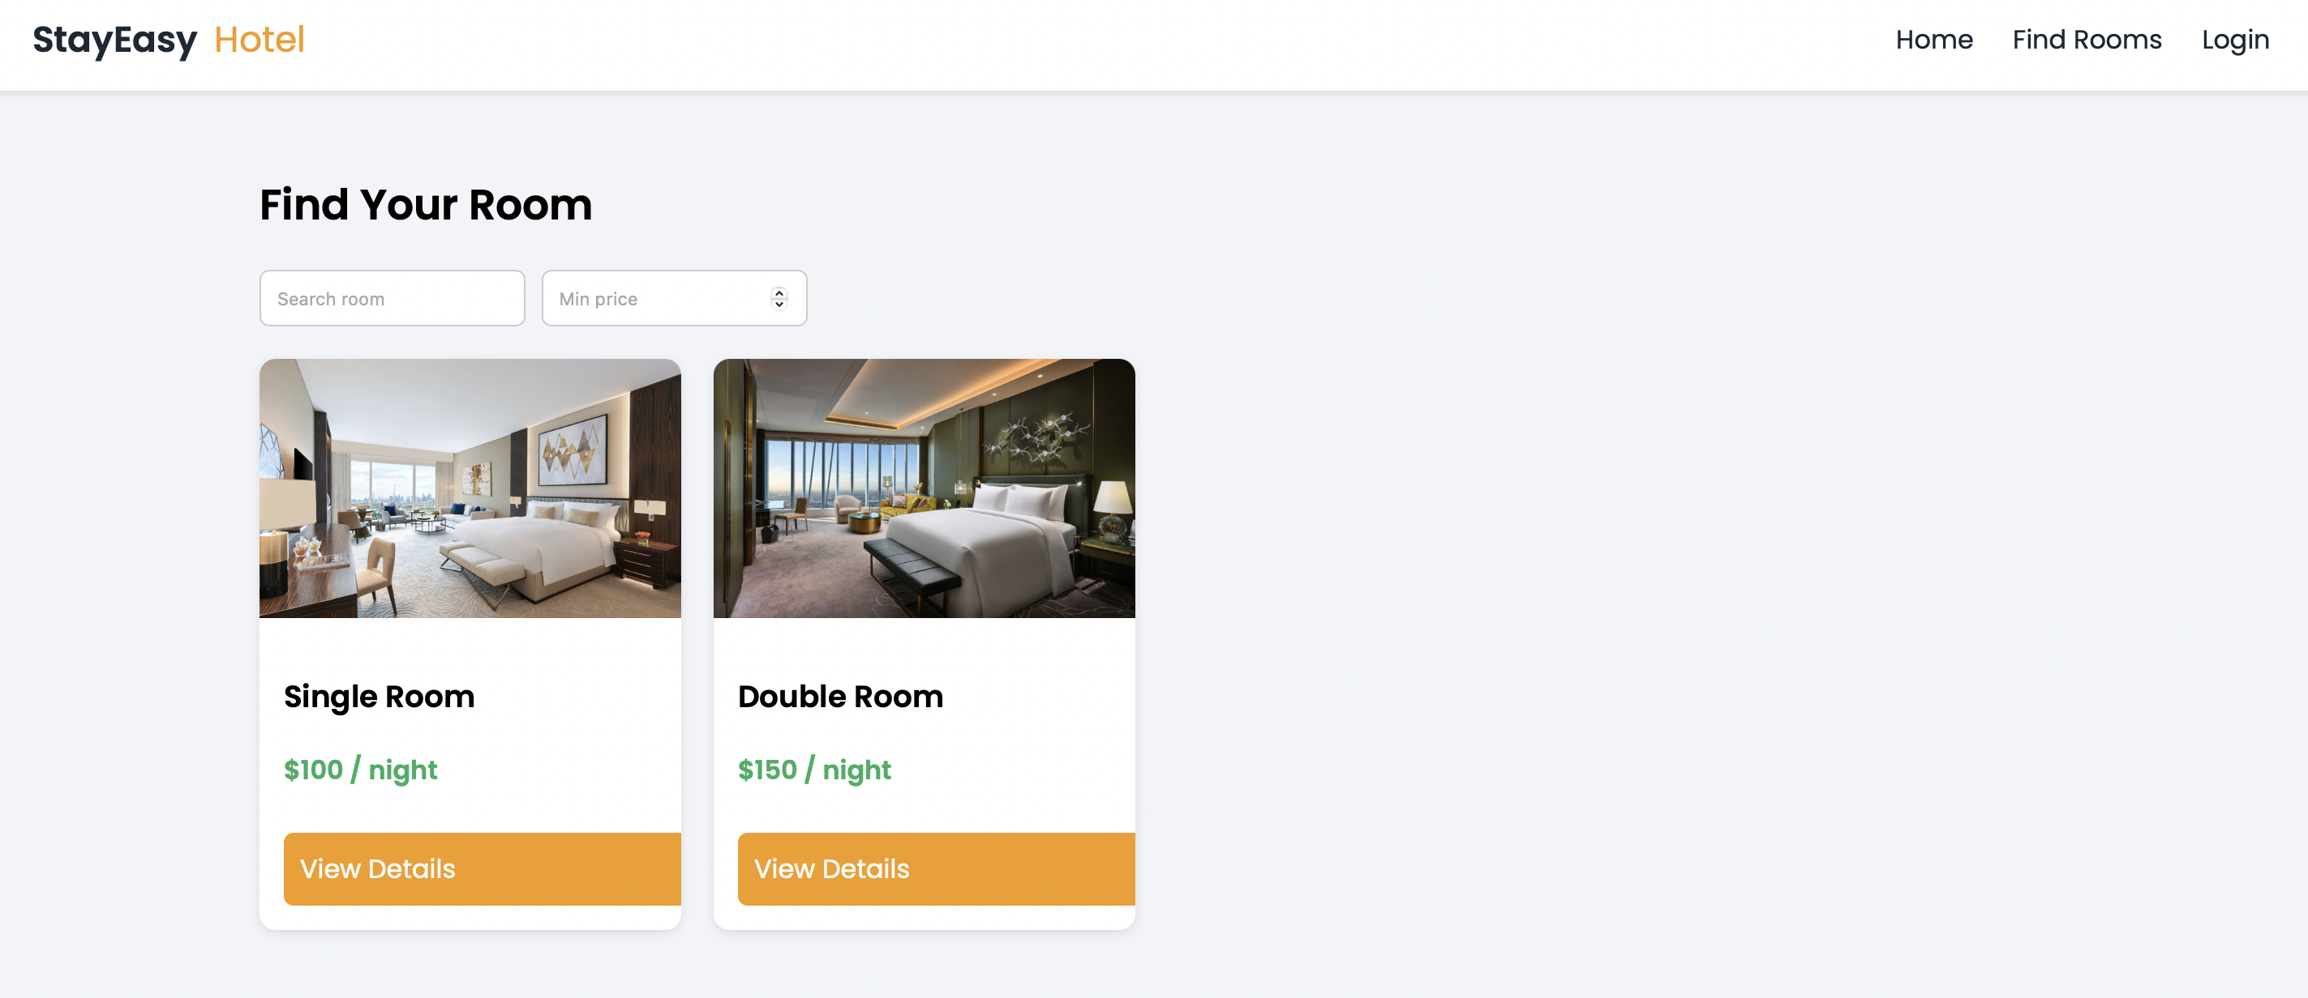

This page displays available hotel rooms from the database. It uses JavaScript (DOM) to filter rooms based on name and price dynamically.

Booking history page :
<?php
session_start();
include("includes/setup.php");

$user=$_SESSION['user'];

if(isset($_GET['cancel'])){
$id=$_GET['cancel'];
mysqli_query($conn,"DELETE FROM bookings_data WHERE id=$id");
}

$res=mysqli_query($conn,"
SELECT bookings_data.id, hotel_rooms.room_name
FROM bookings_data
JOIN hotel_rooms ON bookings_data.room_id = hotel_rooms.id
WHERE bookings_data.user='$user'
");
?>

<html>
<head>
<link rel="stylesheet" href="css/style.css">
<link href="https://fonts.googleapis.com/css2?family=Poppins:wght@300;400;600&display=swap" rel="stylesheet">
</head>
<body>

<?php session_start(); ?>

<header class="main-header">
<div class="logo">StayEasy <span>Hotel</span></div>

<nav>
<a href="index.php">Home</a>
<a href="search_rooms.php">Find Rooms</a>

<?php if(isset($_SESSION['user'])){ ?>
<a href="my_bookings.php">My Bookings</a>
<a href="logout.php">Logout</a>
<?php } else { ?>
<a href="login.php">Login</a>
<?php } ?>
</nav>
</header>

<div class="page-container">

<h2 class="page-title">My Bookings</h2>

<div class="table-box">
<table>
<tr>
<th>ID</th>
<th>Room</th>
<th>Action</th>
</tr>

<?php while($row=mysqli_fetch_assoc($res)){ ?>
<tr>
<td><?php echo $row['id']; ?></td>
<td><?php echo $row['room_name']; ?></td>
<td>
<a class="btn" href="?cancel=<?php echo $row['id']; ?>">Cancel</a>
</td>
</tr>
<?php } ?>

</table>
</div>

</div>
</body>
</html>

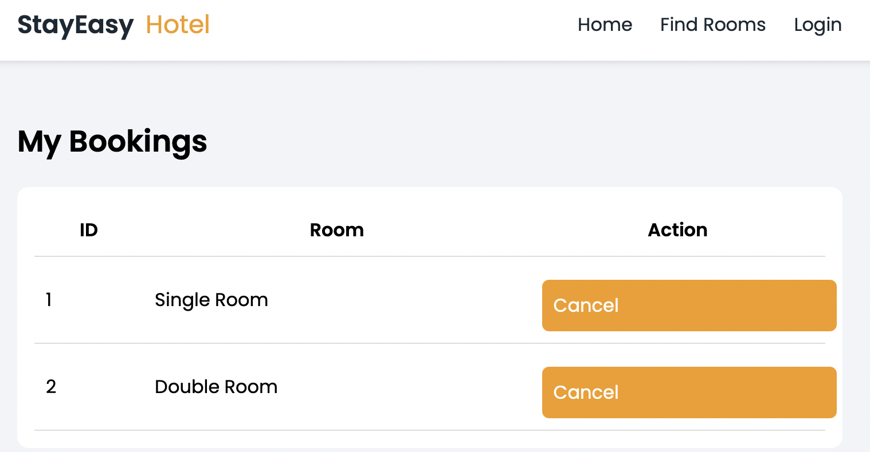

This page shows the user’s bookings using a table. It retrieves data from the database and allows the user to cancel bookings (DELETE).

CSS
3 Marks
Learning Outcome(s):
2. Create web pages using HTML5 and CSS3.

body{
font-family: 'Poppins', sans-serif;
margin:0;
background:#f2f4f8;
}

/* HEADER */
.main-header{
background:white;
color:#1c2833;
display:flex;
justify-content:space-between;
padding:15px 30px;
align-items:center;
box-shadow:0 2px 5px rgba(0,0,0,0.1);
position:sticky;
top:0;
z-index:1000;

}

/* LOGO */
.logo{
font-size:22px;
font-weight:600;
}

.logo span{
color:#f39c12;
font-weight:400;
margin-left:5px;
}

/* NAV LINKS */
nav a{
color:#1c2833;
margin-left:20px;
text-decoration:none;
font-weight:500;
}

nav a:hover{
color:#f39c12;
}

/* CONTAINER */
.page-container{
padding:30px;
max-width:1100px;
margin:auto;
}

.page-title{
font-size:26px;
margin-bottom:20px;
}

/* FILTER */
.filter-box{
display:flex;
gap:10px;
margin-bottom:20px;
}

.filter-box input{
padding:10px;
border:1px solid #ccc;
border-radius:6px;
}

/* GRID */
.room-grid{
display:grid;
grid-template-columns:repeat(auto-fill, minmax(250px,1fr));
gap:20px;
}

/* CARD */
.room-card{
background:white;
border-radius:10px;
overflow:hidden;
box-shadow:0 2px 6px rgba(0,0,0,0.1);
transition:0.3s;
}

.room-card:hover{
transform:translateY(-5px);
}

.room-card img{
width:100%;
height:160px;
object-fit:cover;
}

.room-content{
padding:15px;
}

.price{
color:#27ae60;
font-weight:bold;
}

/* BUTTON */
.btn{
display:inline-block;
margin-top:10px;
padding:8px 15px;
background:#f39c12;
color:white;
border-radius:5px;
text-decoration:none;
border:none;
cursor:pointer;
}

.btn:hover{
background:#d68910;
}

/* BACK BUTTON */
.back-btn{
display:inline-block;
margin-bottom:20px;
text-decoration:none;
color:#333;
}

.back-btn:hover{
color:#f39c12;
}

/* FORM */
.form-box{
width:350px;
margin:80px auto;
background:white;
padding:25px;
border-radius:12px;
box-shadow:0 4px 12px rgba(0,0,0,0.1);
}

.form-box input{
width:100%;
padding:12px;
margin:10px 0;
border:1px solid #ccc;
border-radius:6px;
}

.btn{
width:100%;
padding:10px;
background:#f39c12;
color:white;
border:none;
border-radius:6px;
cursor:pointer;
}

.btn:hover{
background:#d68910;
}

/* TABLE */
.table-box{
background:white;
padding:15px;
border-radius:10px;
}

table{
width:100%;
border-collapse:collapse;
}

td, th{
padding:10px;
border-bottom:1px solid #ddd;
}

This file controls the design of the website including layout, colors, spacing, buttons, and responsiveness. It ensures consistent styling across all pages.

JavaScript
2 Marks
Learning Outcome(s):
3. Develop dynamic web pages using JavaScript.

/ ==========================
// REGISTER VALIDATION
// ==========================
function validateForm(){
let u = document.getElementById("user").value;
let p = document.getElementById("pass").value;

if(u==""){
alert("Username is required");
return false;
}

if(p==""){
alert("Password is required");
return false;
}

if(p.length < 4){
alert("Password must be at least 4 characters");
return false;
}

return true;
}

// ==========================
// ROOM FILTER (SEARCH PAGE)
// ==========================
function filterRooms(){
let input = document.getElementById("searchBox").value.toLowerCase();
let minPrice = document.getElementById("minPrice").value;
let cards = document.getElementsByClassName("room-card");

for(let i=0;i<cards.length;i++){
let text = cards[i].innerText.toLowerCase();
let price = cards[i].getAttribute("data-price");

if(text.includes(input) && (minPrice=="" || price >= minPrice)){
cards[i].style.display = "block";
} else {
cards[i].style.display = "none";
}
}
}

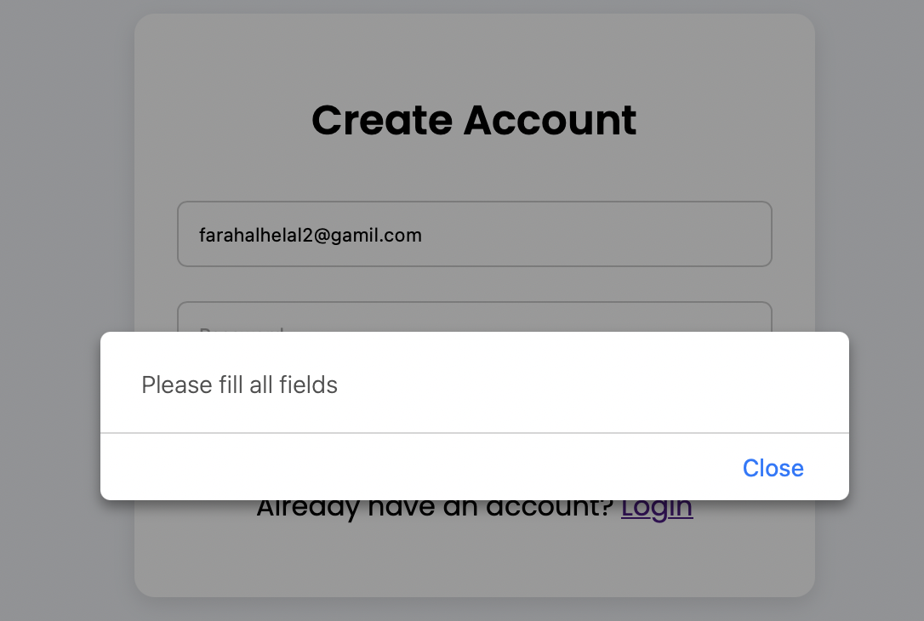

Register page ERROR

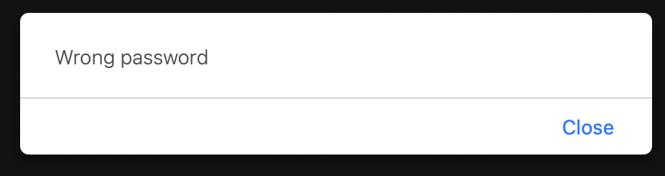

Login page ERROR

This file contains JavaScript functions used for form validation. It checks user inputs and displays alert messages if there are errors.

The project uses DOM (Document Object Model) in JavaScript to interact with HTML elements.

Examples of DOM usage in the project:

1.⁠ ⁠Accessing form inputs:
document.getElementById("regUser").value
document.getElementById("regPass").value

2.⁠ ⁠Accessing form fields:
form.email.value
form.password.value

3.⁠ ⁠Reading search input:
document.getElementById("searchBox").value

4.⁠ ⁠Getting elements:
document.getElementsByClassName("room-card")

5.⁠ ⁠Reading content:
cards[i].innerText

6.⁠ ⁠Getting attributes:
cards[i].getAttribute("data-price")

7.⁠ ⁠Changing display:
cards[i].style.display = "none"
cards[i].style.display = "block"

These DOM methods are used to validate forms, filter rooms, and control the display of elements dynamically.

PHP + MySQL
5 Marks
Learning Outcome(s):
6. Build web applications using PHP and MySQL.

1. DataBase creation

CREATE DATABASE stayeasy_db;

USE stayeasy_db;

CREATE TABLE users_simple(
id INT AUTO_INCREMENT PRIMARY KEY,
username VARCHAR(50),
password VARCHAR(100)
);

CREATE TABLE hotel_rooms(
id INT AUTO_INCREMENT PRIMARY KEY,
room_name VARCHAR(100),
price INT,
img VARCHAR(100)
);

CREATE TABLE bookings_data(
id INT AUTO_INCREMENT PRIMARY KEY,
user VARCHAR(50),
room_id INT
);

Hotel Rooms table
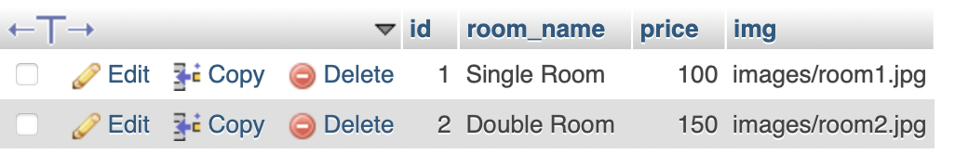

User table
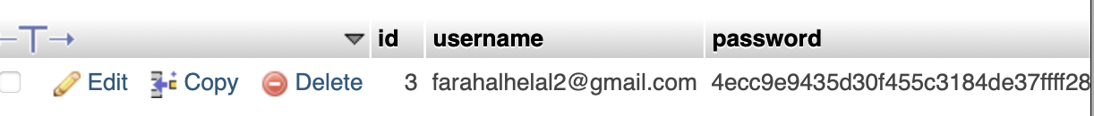

Bookings table
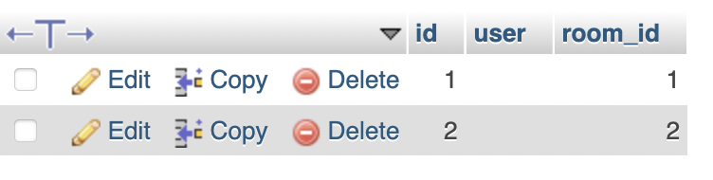

The database is created using MySQL and contains three tables: users, rooms, and bookings.

2. SQL Select :

$res = mysqli_query($conn,"SELECT * FROM hotel_rooms");

$res=mysqli_query($conn,"
SELECT bookings_data.id, hotel_rooms.room_name
FROM bookings_data
JOIN hotel_rooms ON bookings_data.room_id = hotel_rooms.id
WHERE bookings_data.user='$user'
");

3.INSERT Query :

mysqli_query($conn,"INSERT INTO bookings_data(user,room_id) VALUES('$user',$id)");

4. DELET Query :

mysqli_query($conn,"DELETE FROM bookings_data WHERE id=$id");

5. UPDATE Query :

mysqli_query($conn,"UPDATE hotel_rooms SET price=200 WHERE id=1");

These SQL operations are used to manage data:
• SELECT: retrieve rooms and bookings
• INSERT: add new booking
• UPDATE: modify data
• DELETE: remove booking

6.DataBase Connection :

$conn = mysqli_connect("localhost","root","","stayeasy_db");

This connects the website to the MySQL database using PHP mysqli.

